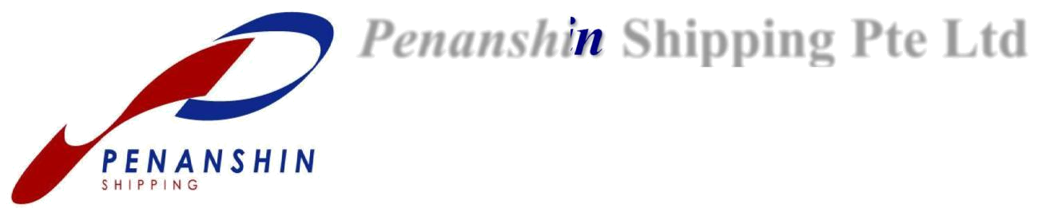
PENANSHIN Shipping Pte Ltd

Blk 511, Kampong Bahru Road, #05-01/06 Keppel Distripark, Singapore

099447.
Tel: 6221 2992 (Main Line) | Fax: 6372 1243 | (Sales & Cus. Svc)
www.penanshin.com. | 6372 1589 | (Export)
general@penanshin.com.sg | 6324 2919 | (Import)
 | 6227 5509 | (Accounts)

BMSB (Brown Marmorated Stink Bug) declaration - Australia

Bill of Lading: ……………………………………...

We hereby declare that the goods sent under above bill of lading has met the following criteria.

Information pertaining below requirements can be found on the website of the Department of Agriculture and Water Resources (DAWR) of the Australian Government: http://www.agriculture.gov.au/import/before/pests/brown-marmorated-stink-bugs

- Target risk country (USA, Italy, Germany, France, Russia, Greece, Hungary, Romania, Georgia, Japan)

Goods are originating from or manufactured in a country listed as ‘target risk country’ by ‘DAWR’.

YES NO

- Target high risk goods (Explosives, pyrotechnics, Copper, Machinery, Wood, Nickel, Cork, Aluminums, E-Goods, Railway locos, Carpets, Lead, Vehicles, Stone, cement, Zinc, Aircraft, Ceramics, Tin, Ships, Glass, Base metals, Steel, iron, Tools, cutlery, Steel articles, Base metal)

Goods categorized as ‘target high risk goods’ by ‘DAWR’.

YES NO

If any YES has been circled, a treatment certificate for the specific consignment is required. This must meet the requirements as per DAWR standards.

Certificate No.: ……………………………. AEI: …………………………………………...

Note: certificate must be issued by an approved BSBM treatment provider, which please find via following link: (http://www.agriculture.gov.au/import/before/pests/brown-marmorated-stink-bugs/offshore-treatment-providers)

Non-compliance to the BMSB-measures may lead to return, destruction and/or additional treatment of the goods or complete container. All costs related will be passed onto shippers who have not complied with treatment or mis-declared their cargo.

Kindly note that Penanshin cannot be held responsible for non-adherence and shall not bear any expenses for return, destruction and/or treatment.

Signed by: ……………………………………. Company name & stamp: ……………………………

Date of issue: ………………………………… Signature: …………………………………...................

All business is transacted only in accordance with our Standard Trading Terms and Conditions. (Latest Edition)

